---------------------------------------- CODE-------------------------------------------

#PYTHON MODULES

import cv2

import numpy as np

import os

import matplotlib.pyplot as plt

import os.path

from os import path

import sqlite3

from tkinter import *

from PIL import ImageTk, Image

#PYTHON DATABASE

conn = sqlite3.connect("imagedb.db") # or use :memory: to put it in RAM

cursor = conn.cursor()

# create a table

cursor.execute("""CREATE TABLE test4

(id int, img_path text, eyes int, faces int)

""")

img_folder_path = 'img/'

imgPaths = [img_folder_path+name for name in os.listdir(img_folder_path) if not name[0] == '.']

print(imgPaths)

#FACE DETECTION CODE

n=0

for i in imgPaths:

if path.exists(i):

n=n+1

cursor.execute("INSERT INTO test4 VALUES(?,?,?,?)", (n, i, 0, 0))

conn.commit()

cursor.execute("SELECT * FROM test4")

rows = cursor.fetchall()

print(rows)

print(n)

n=2

faces = []

'''

for img in imgPaths:

print(img)

img = cv2.imread(img)

'''

for i in range(n):

e = 0

f = 0

i+=1

sql="Select img_path from test4 where id=?"

cursor.execute(sql,[(i)])

img_list = cursor.fetchall()

img = (img_list[0])

ig = img[0]

img = cv2.imread(img[0])

face_cascade = cv2.CascadeClassifier("utils/haarcascade_frontalface_default.xml")

eye_cascade = cv2.CascadeClassifier('utils/haarcascade_eye.xml')

plt.imshow(cv2.cvtColor(img, cv2.COLOR_BGR2RGB))

plt.show()

img = cv2.cvtColor(img, cv2.COLOR_BGR2RGB)

gray = cv2.cvtColor(img, cv2.COLOR_BGR2GRAY)

detected_faces = face_cascade.detectMultiScale(gray)

for(x, y, w, h) in detected_faces:

roi_gray = gray[y:y+h, x:x+w]

roi_color = img[y:y+h, x:x+w]

eyes = eye_cascade.detectMultiScale(roi_gray)

if len(eyes) > 1:

faces.append(np.array(roi_color))

cv2.rectangle(img,(x,y),(x+w,y+h),(255,0,0),2)

f += 1

for (ex,ey,ew,eh) in eyes:

cv2.rectangle(roi_color,(ex,ey),(ex+ew,ey+eh),(0,255,0),2)

e+=1

plt.imshow(img)

plt.show()

print("Number of eyes in given picture:", e)

print("Number of faces in given picture", f)

#UPDATING DATABASE

sql = "UPDATE test4 SET eyes =?, faces =? WHERE img_path =? "

cursor.execute(sql, [(e),(f),(ig)])

conn.commit()

#DISPLAYING IN TKINTER

root = Tk()

i=1

sql="Select * from test4 where id=?"

cursor.execute(sql,[(i)])

img_list = cursor.fetchall()

img = (img_list[0])

im = img[1]

fa = img[3]

ey = img[2]

panel = Label(root, text=("Image:",img[1]))

panel.pack(side = "top", fill = "both", expand = "yes")

img = ImageTk.PhotoImage(Image.open(im))

panel = Label(root, image = img)

panel.pack(side = "top", fill = "both", expand = "yes")

panel = Label(root, text=("Number of faces recognized:",fa))

panel.pack(side = "top", fill = "both", expand = "yes")

panel = Label(root, text=("Number of eyes recognized:",ey))

panel.pack(side = "top", fill = "both", expand = "yes")

root.mainloop()

root = Tk()

i=2

sql="Select * from test4 where id=?"

cursor.execute(sql,[(i)])

img_list = cursor.fetchall()

img = (img_list[0])

im = img[1]

fa = img[3]

ey = img[2]

panel = Label(root, text=("Image:",img[1]))

panel.pack(side = "top", fill = "both", expand = "yes")

img = ImageTk.PhotoImage(Image.open(im))

panel = Label(root, image = img)

panel.pack(side = "top", fill = "both", expand = "yes")

panel = Label(root, text=("Number of faces recognized:",fa))

panel.pack(side = "top", fill = "both", expand = "yes")

panel = Label(root, text=("Number of eyes recognized:",ey))

panel.pack(side = "top", fill = "both", expand = "yes")

root.mainloop()

---------------------------------------- OUTPUT-------------------------------------------

DISPLAYING FILES USING OS MODULE

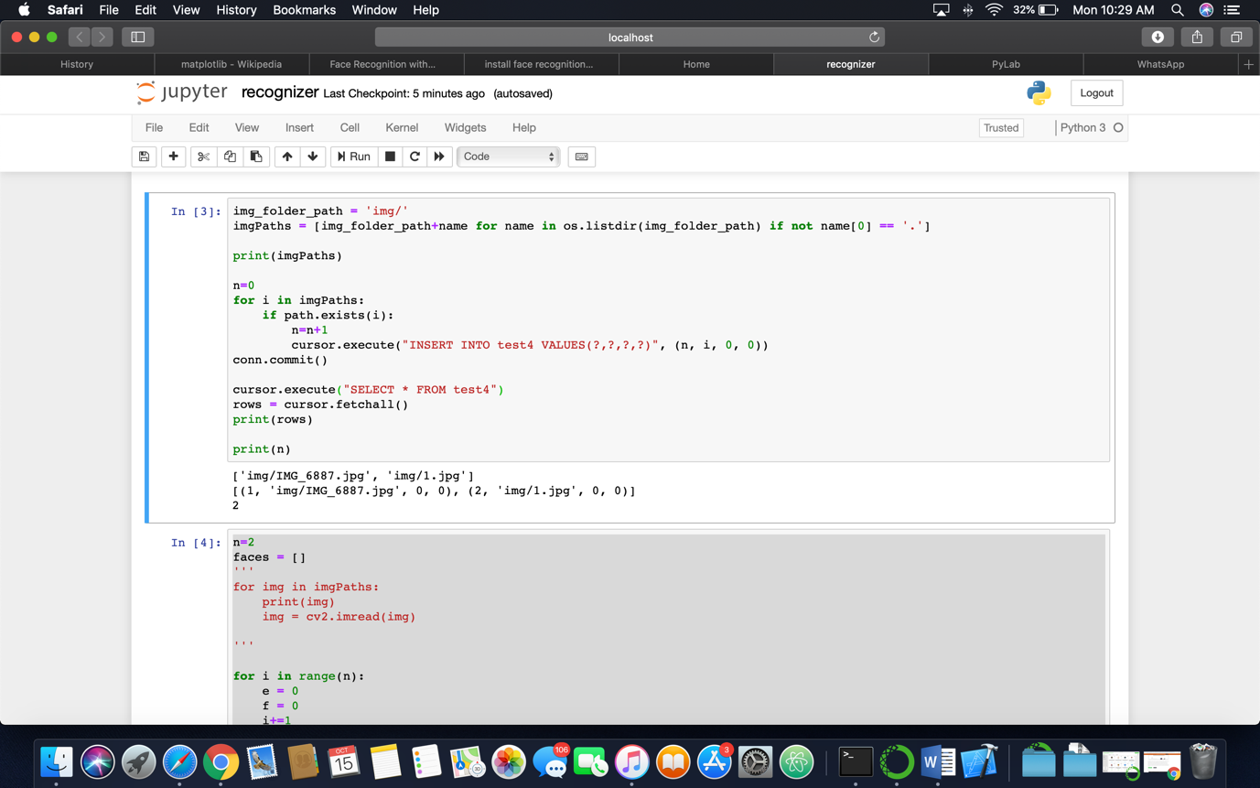

PLOTTING AND DETECTION OF FACES AND EYES IN AN IMAGE

* EXAMPLE 1:

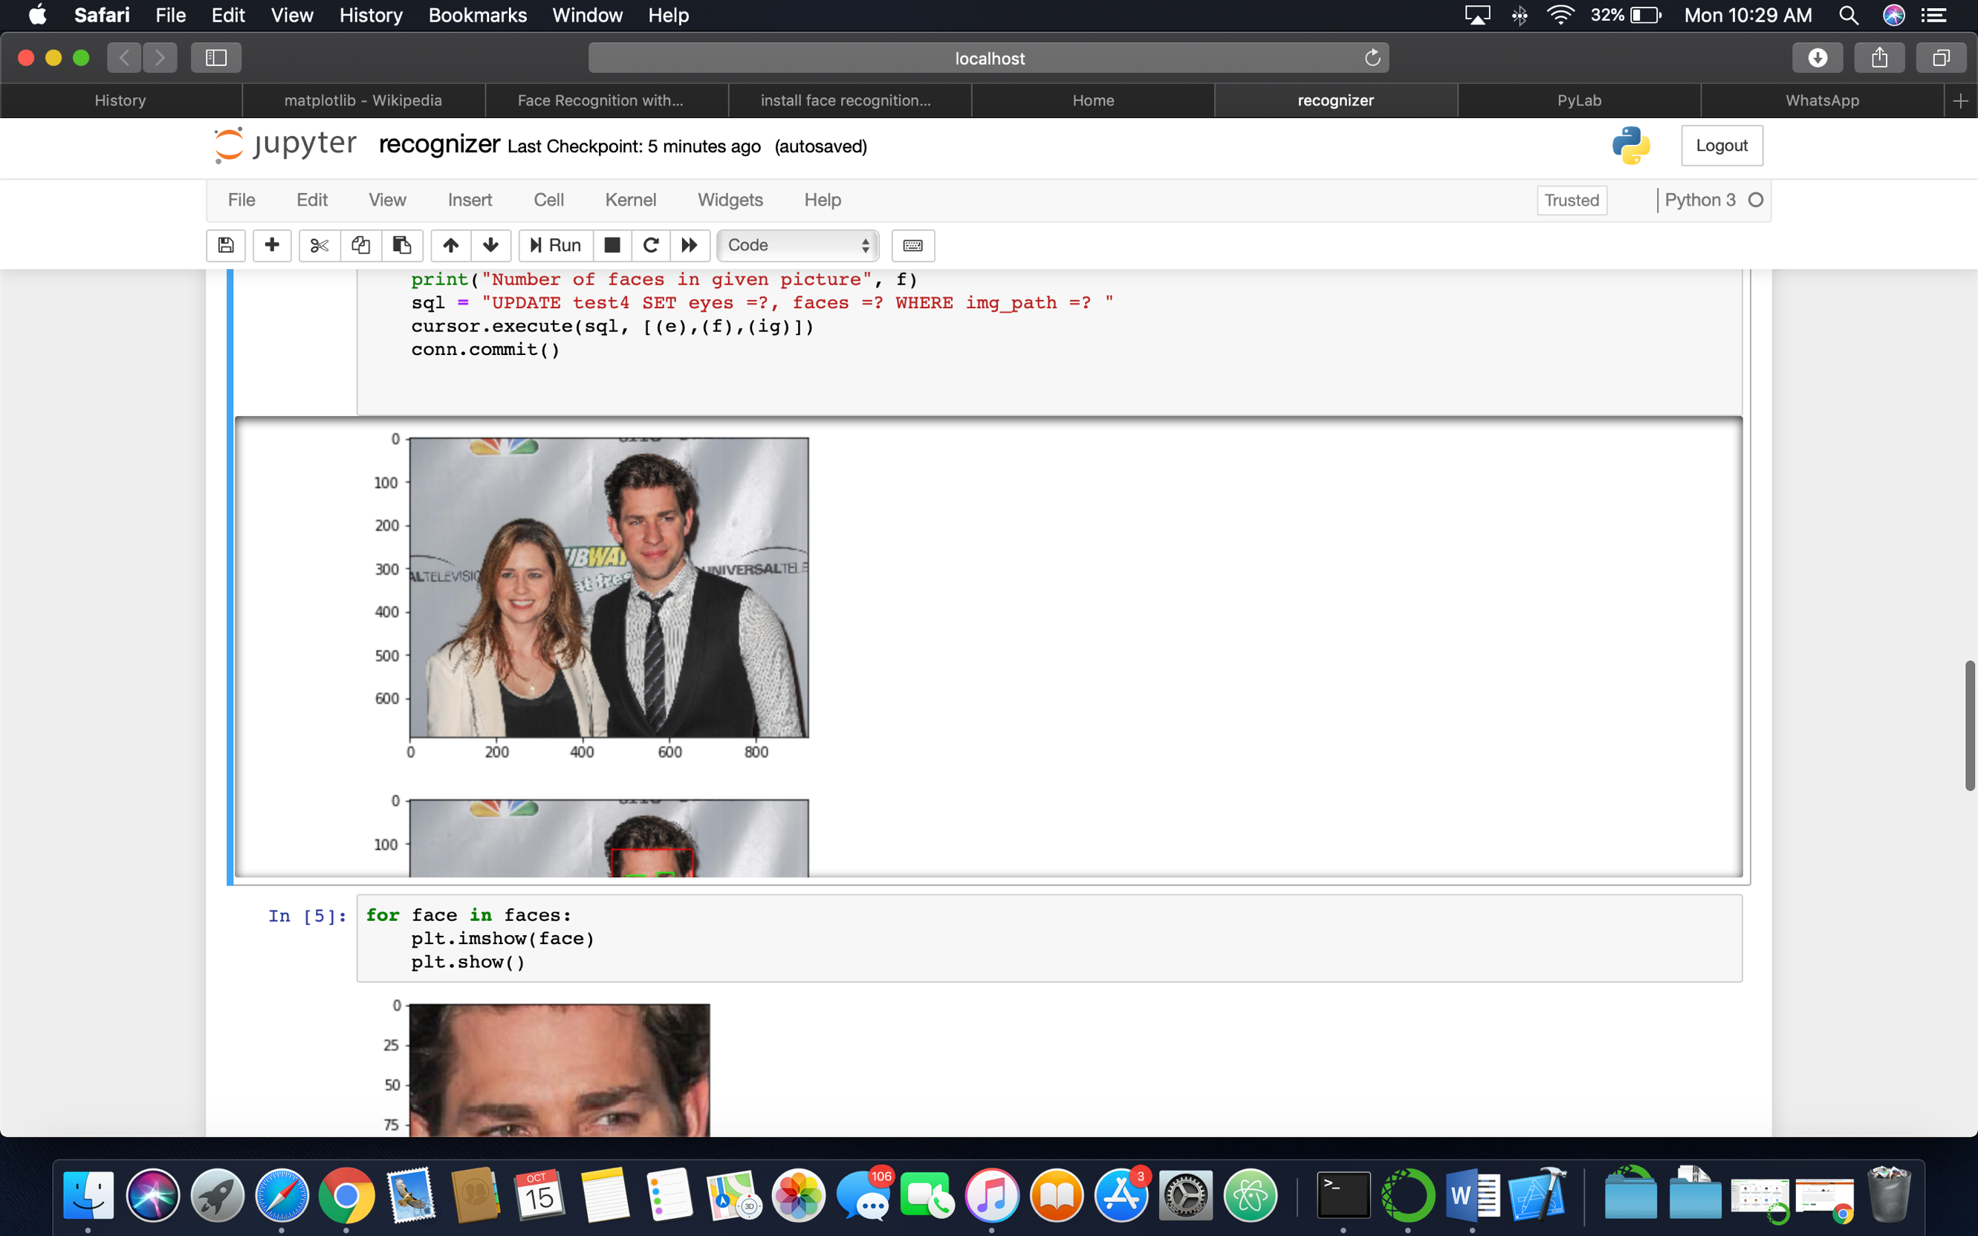

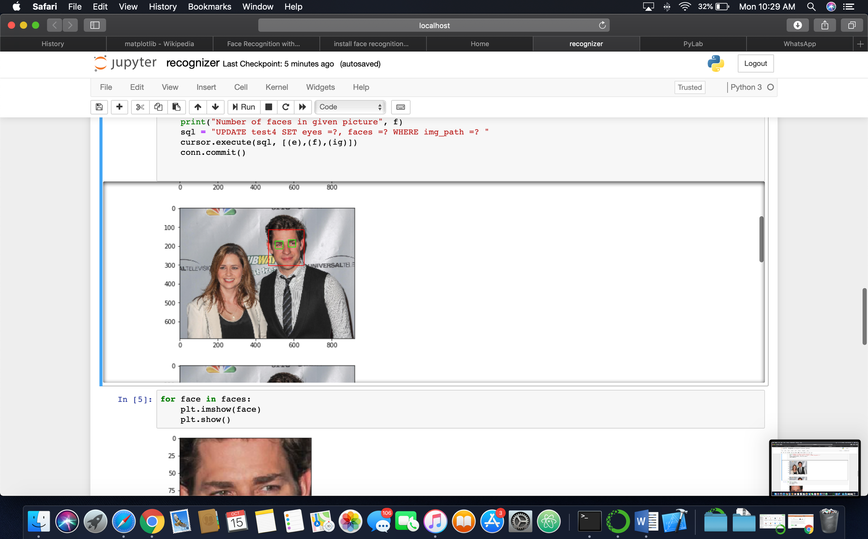

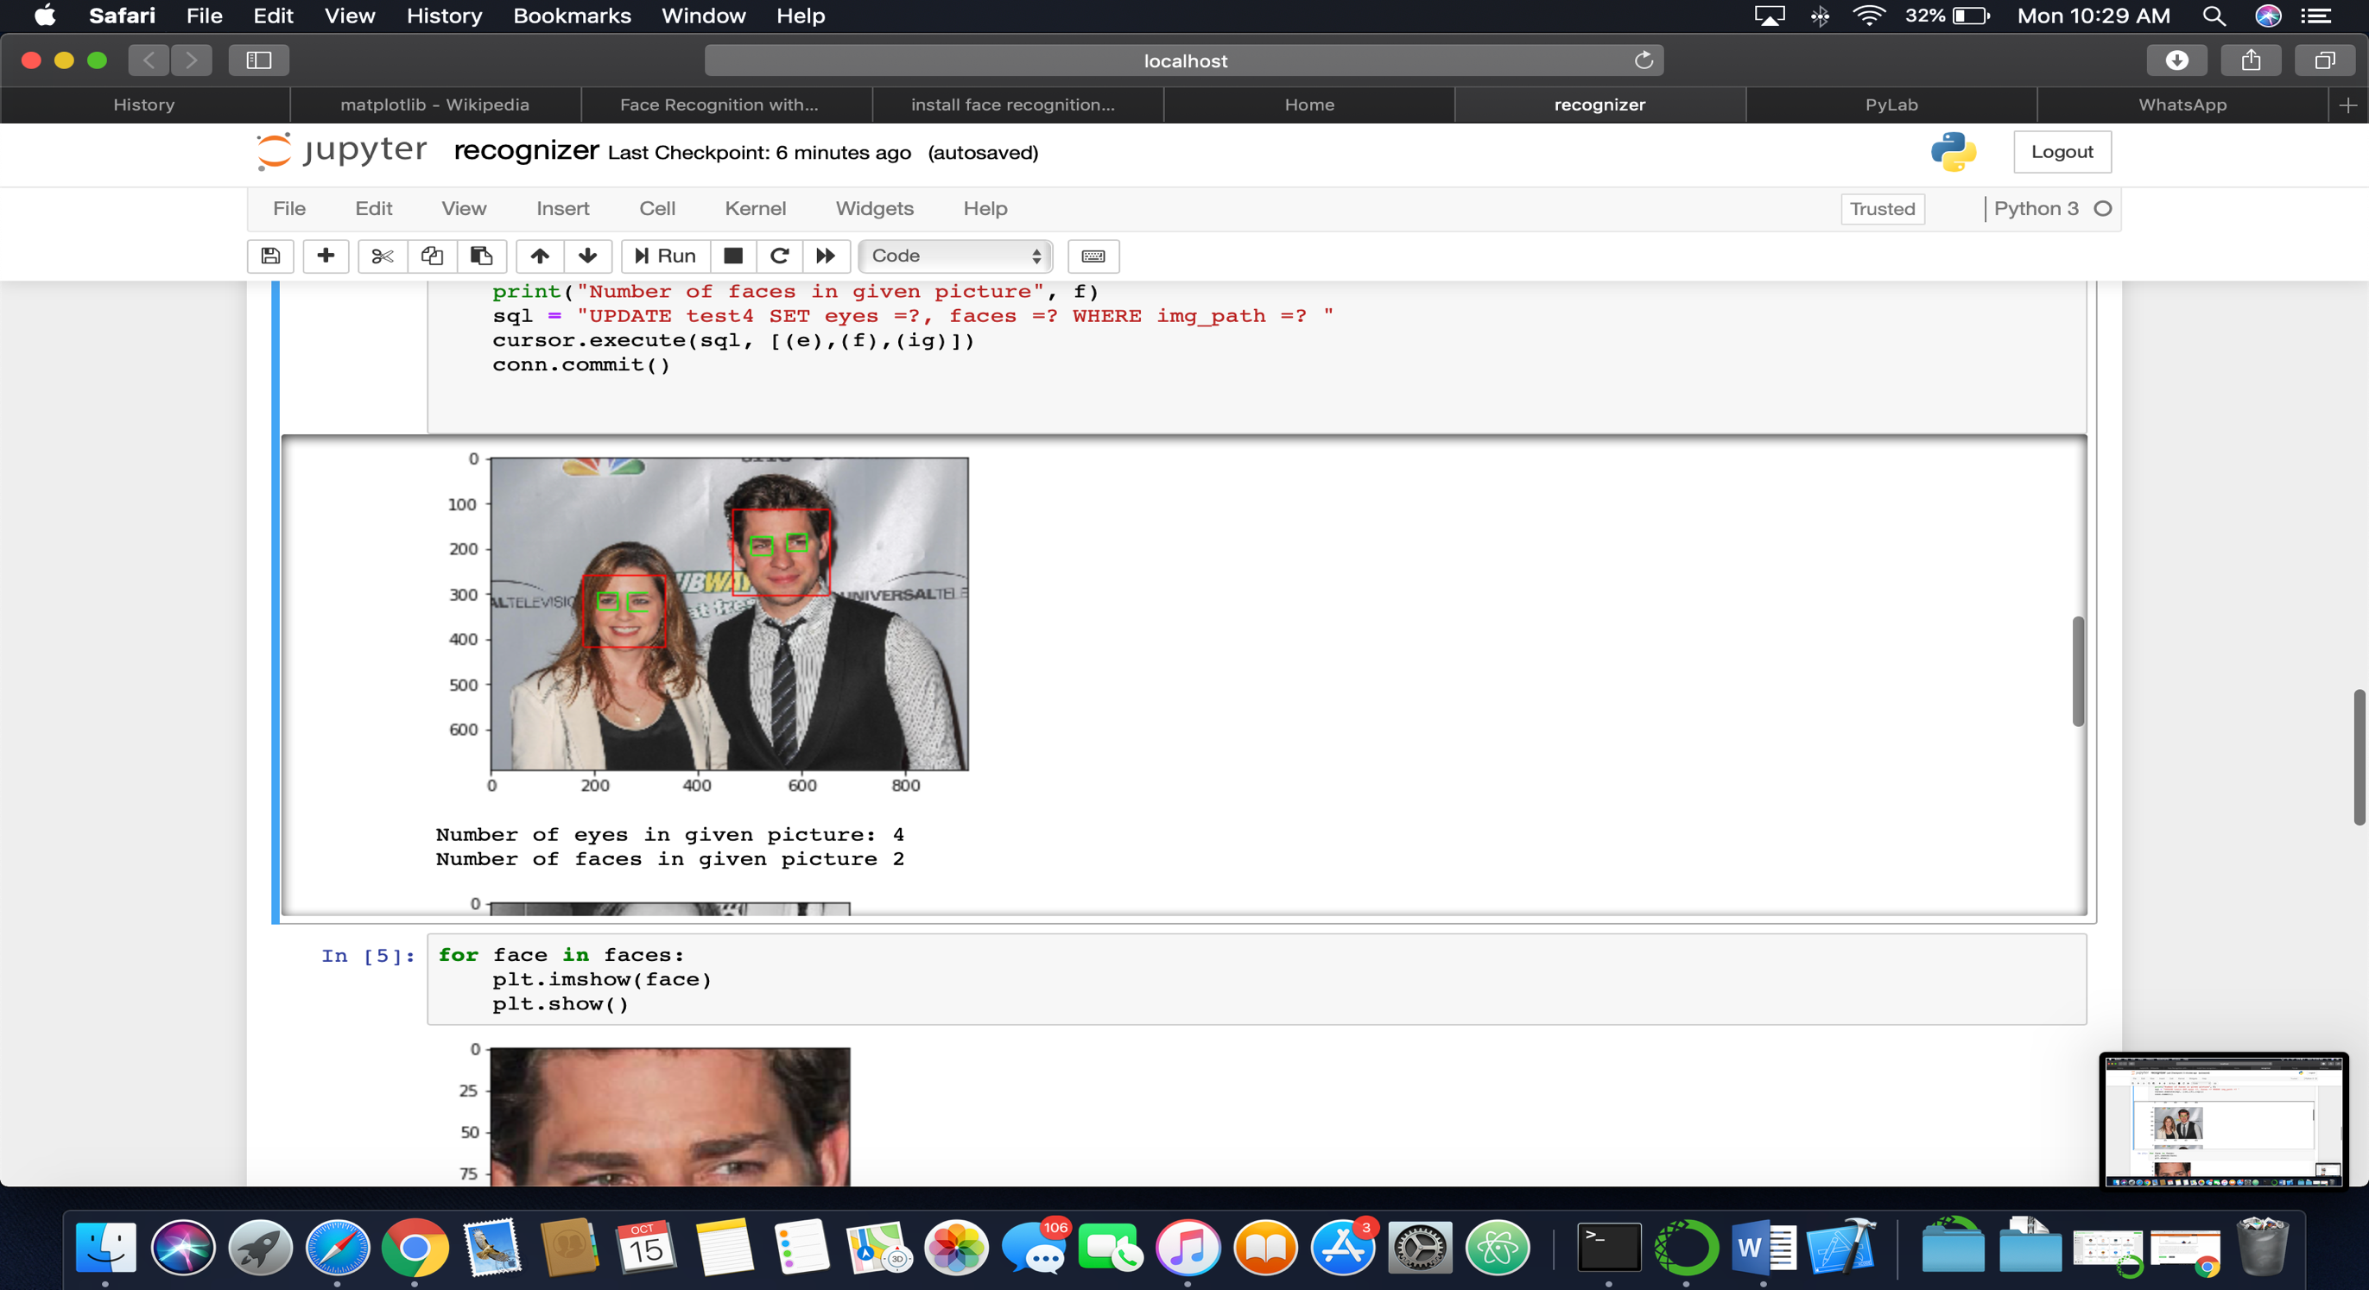

* EXAMPLE 2:

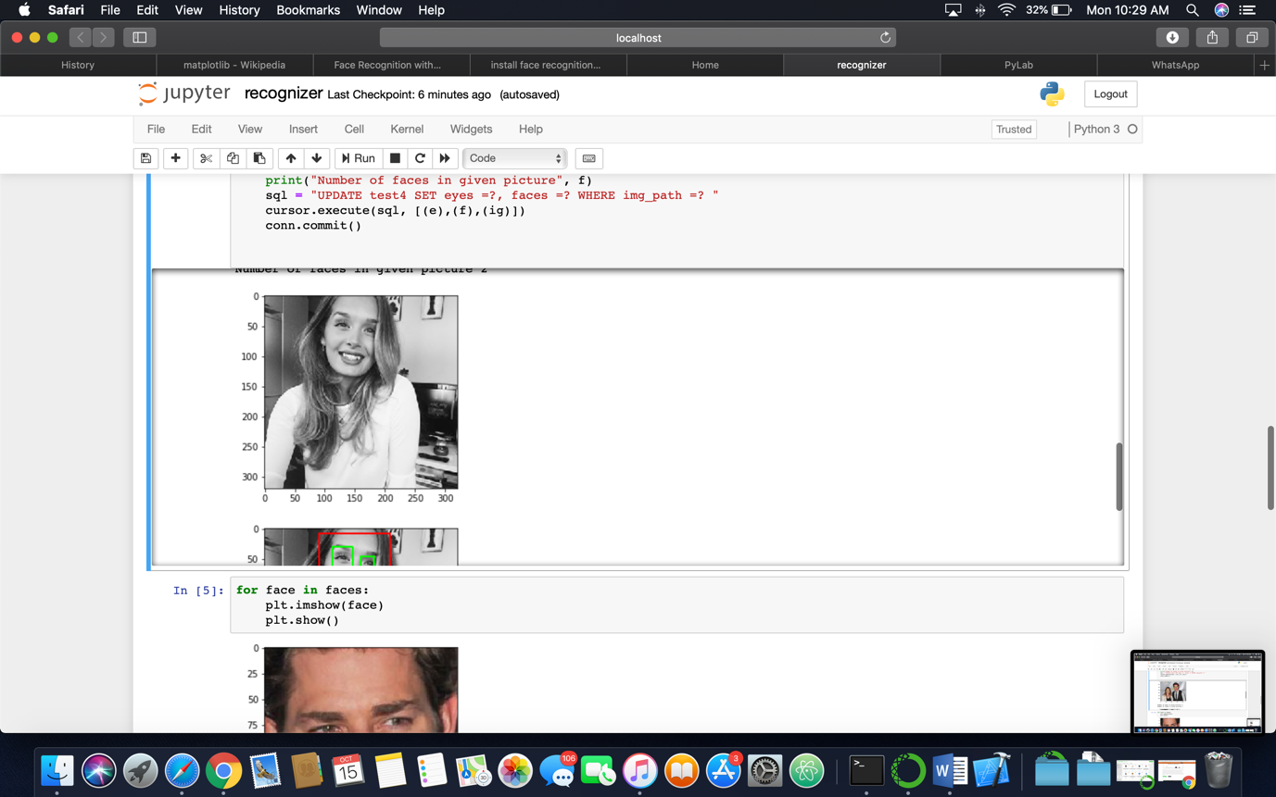

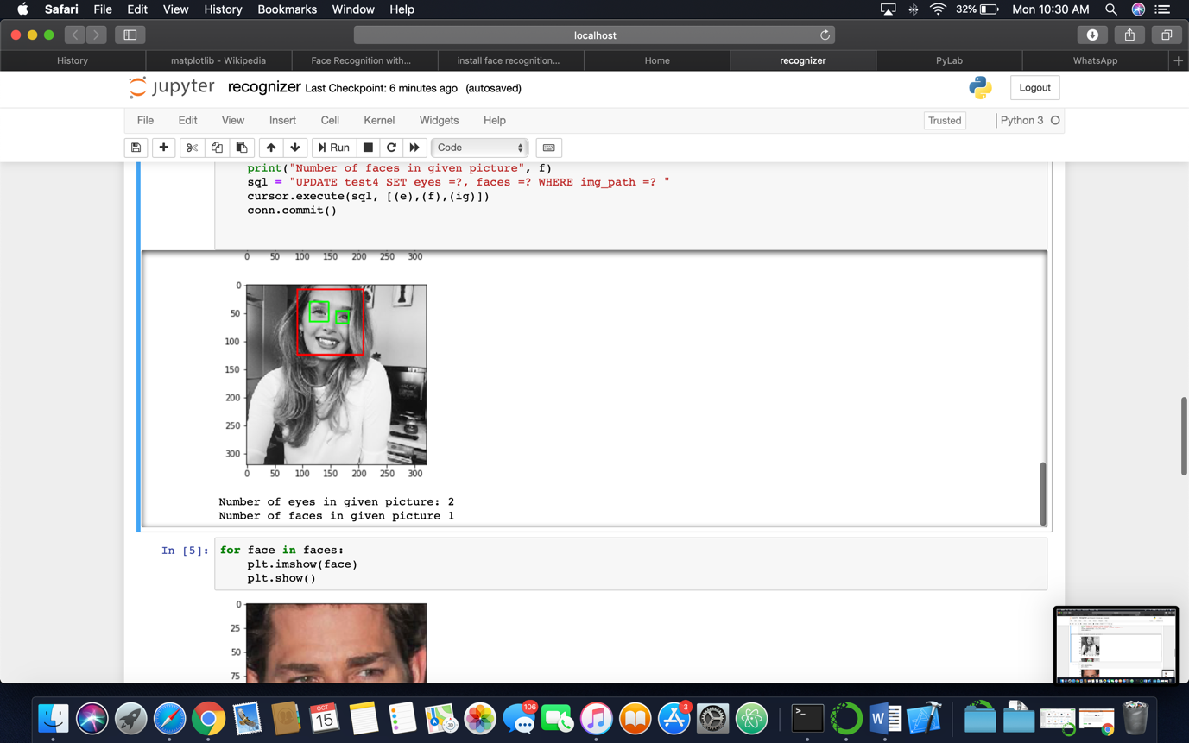

DISPLAYING ALL THE FACES DETECTED

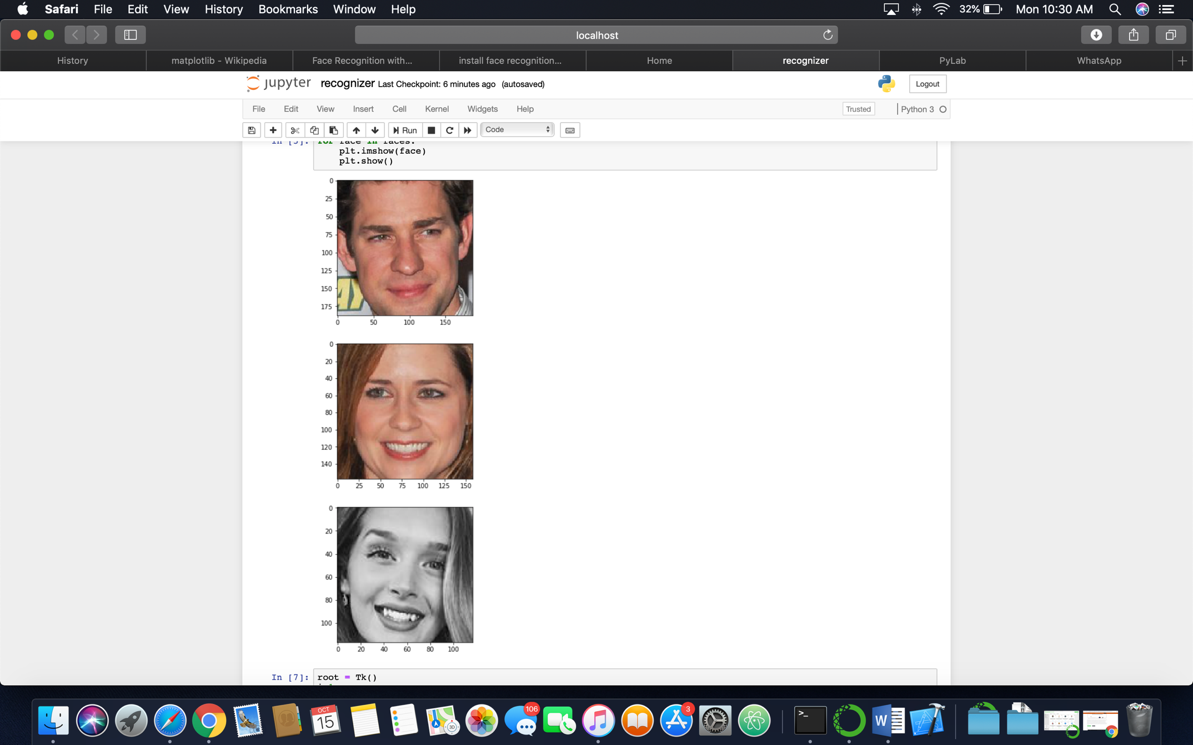

DISPLAYING THE RESULTS IN TKINTER:

